Verification of Ohm’s Law using PSPICE Simulation

LAB # 3



Spring 2022

CIRCUIT AND SYSTEMS 1 LAB

Submitted by: MUHAMMAD SADEEQ

Registration No.: 21PWCSE2028

Section: C

"On my honor, as student of University of Engineering and Technology, I have neither given nor received unauthorized assistance on this academic work.'

Submitted to:

Engr. Faiz Ullah

(April 21, 2022)

Department of Computer Systems Engineering University of Engineering and Technology, Peshawar

**ASSESSMENT RUBRICS LAB # 03**

**Verification of Ohm’s law Using PSPICE**

|  |  |  |  |  |
| --- | --- | --- | --- | --- |
| **LAB REPORT ASSESSMENT** | | | | |
| **Criteria** | **Excellent** | **Average** | **Nil** | **Marks**  **Obtained** |
| **1. Objectives of Lab** | All objectives of lab are properly covered  [Marks 1] | Objectives of lab are partially covered  [Marks 0.5] | Objectives of lab are not  shown |  |
| **2. Ohm’s Law and**  **Mathematical Expression.** | Correct definition of Ohm’s law, mathematical expression and circuit diagram is shown.  [Marks 1] | Correct statement of Ohm’s law and no mathematical expression and circuit diagram with no labels.  [Marks 0.5] | [Marks 0]  No definition, mathematical expression and circuit diagram is shown [Marks 0] |  |
| **3. PSPICE and its Procedure.** | Elaborate PSPICE software and its procedure for designing circuit.  [Marks 2] | PSPICE is not defined while its procedure is not properly discussed [Marks 1] | No Definition or procedure. [Marks 0] |  |
| **4. Circuit**  **Diagram in PSPICE.** | Circuit diagrams for all cases of varying resisters and source voltages are shown with titles and labels in PSPICE.  [Marks 2] | Some of the cases of varying resisters and source voltages are shown with no titles and labels in PSPICE  [Marks 1] | No circuit diagrams are shown  [Marks 0] |  |
| **5. Observations**  **&**  **Calculations** | All experimental results are completely shown in form of table. [Marks 2] | Experimental results are partially shown and some of the observations are missing.  [Marks 1] | No experimental results are shown [Marks 0] |  |
| **6. Graphs** | Graphs from experimental results of Ohm’s law are shown with labels. [Marks 1] | Graphs from experimental results of Ohm’s law are shown with no labels .  [Marks 0.5] | No graphs are shown  [Marks 0] |  |
| **7. Conclusion** | Conclusion about experimental results is properly explained and satisfactory. [Marks 1] | Conclusion about experimental results is not properly explained and satisfactory. [Marks 0.5] | No conclusion is shown [Marks 0] |  |
| Total Marks Obtained:__________  Instructor Signature: ______________________ | | | | |

**Experiment # 3**

Verification of Ohm’s Law using PSPICE Simulation

**Objective:**

To verify ohm’s law on electric circuit simulation tool like PSPICE

**Ohm’s Law:**

**Ohm's law** states that the [current](https://en.wikipedia.org/wiki/Electric_current) through a [conductor](https://en.wikipedia.org/wiki/Electrical_conductor) between two points is directly [proportional](https://en.wikipedia.org/wiki/Proportionality_(mathematics)) to the [voltage](https://en.wikipedia.org/wiki/Voltage) across the two points. Introducing the constant of proportionality, the [resistance](https://en.wikipedia.org/wiki/Electrical_resistance), one arrives at the usual mathematical equation that describes this relationship:



where *I* is the current through the conductor in units of [amperes](https://en.wikipedia.org/wiki/Ampere), *V* is the voltage measured *across* the conductor in units of [volts](https://en.wikipedia.org/wiki/Volt), and *R* is the [resistance](https://en.wikipedia.org/wiki/Electrical_resistance) of the conductor in units of [ohms](https://en.wikipedia.org/wiki/Ohm).

**Circuit Diagram:**

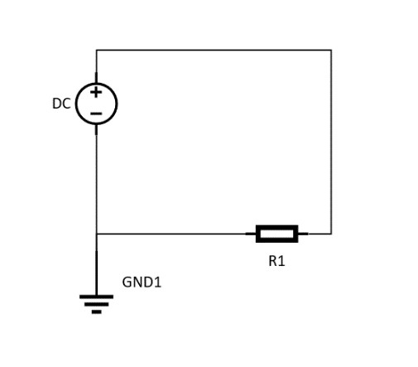

**PSPICE:**

**Pspice** is a circuit analysis tool that allows the user to simulate a circuit and extract key voltages and currents. Information is entered into PSPICE via one of two methods; they are a typed 'Net List' or by designing a visual a schematic which is transformed into a netlist.

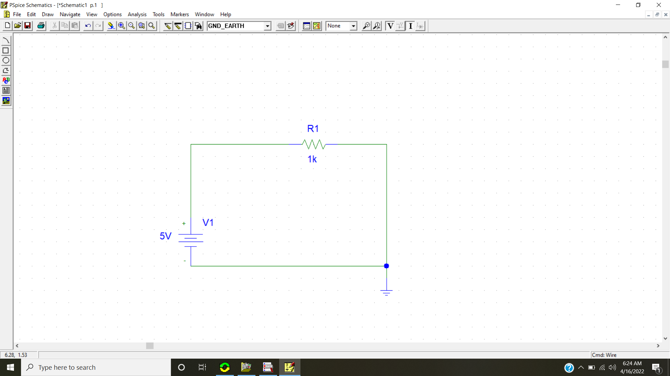

Fig PSPICE

We can verify ohm’s law using PSPICE.

**Procedure:**

1. Open PSPICE schematics.
2. Click on the “Get new part” button in the tool bar.
3. Type “r” and click “Place” button then toggle your mouse to the position where you want to place the resistor in your circuit.
4. Type “VDC” and click “Place” button then toggle your mouse to the position where you want to place the battery in your circuit.
5. Type “GND_EARTH” and click “Place” button then toggle your mouse to the position where you want to place the ground outlet in your circuit.
6. Now connect the components using the “Draw wire” tool from the tool bar.
7. Click the “Simulate” button from the tool to simulate your circuit.
8. Click the “Enable bias voltage display” and “Enable bias current display” buttons from the tool bar to take the readings from the circuit.

**Circuit diagrams:**

**5 Volt DC source and 12k Resistor**

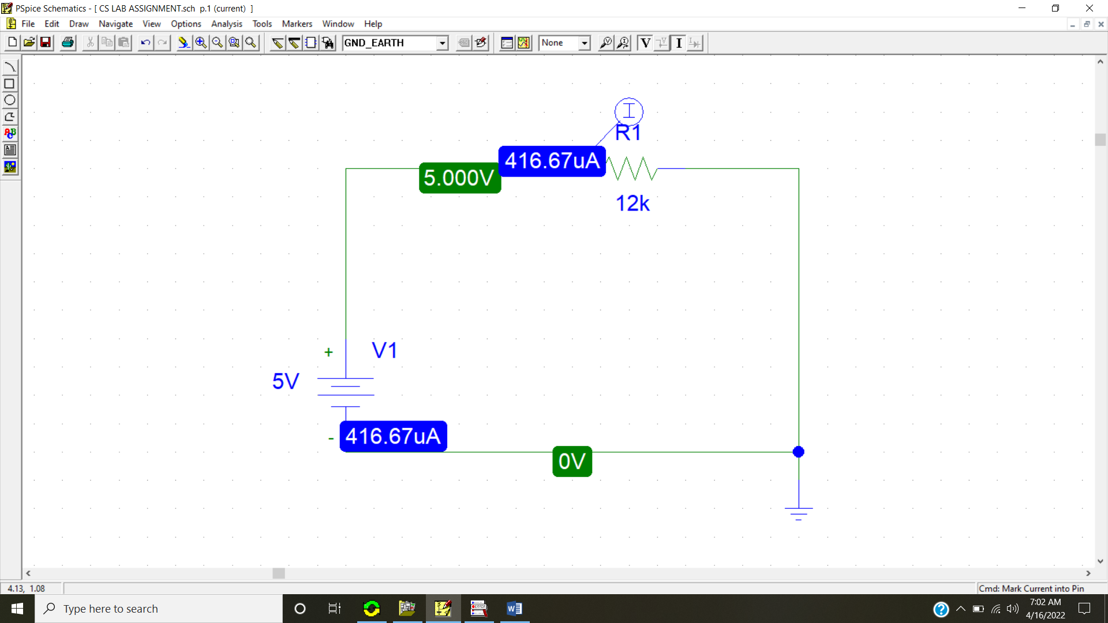

**10 Volt DC source and 12k Resistor**

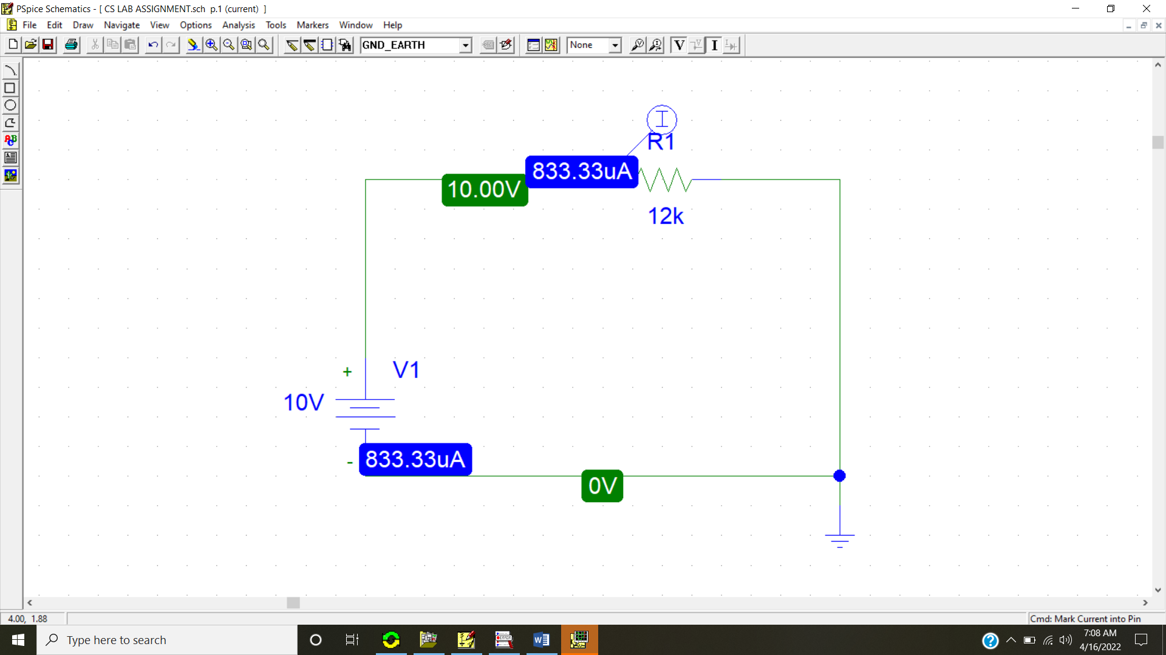

**15 Volt DC source and 12k Resistor**

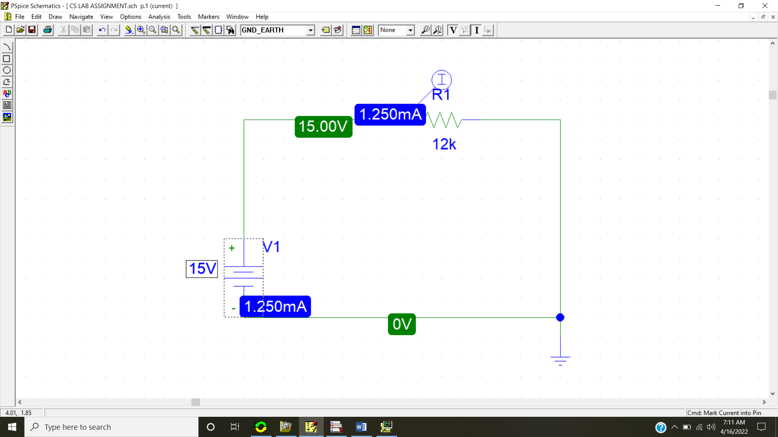

**20 Volt DC source and 12k Resistor**

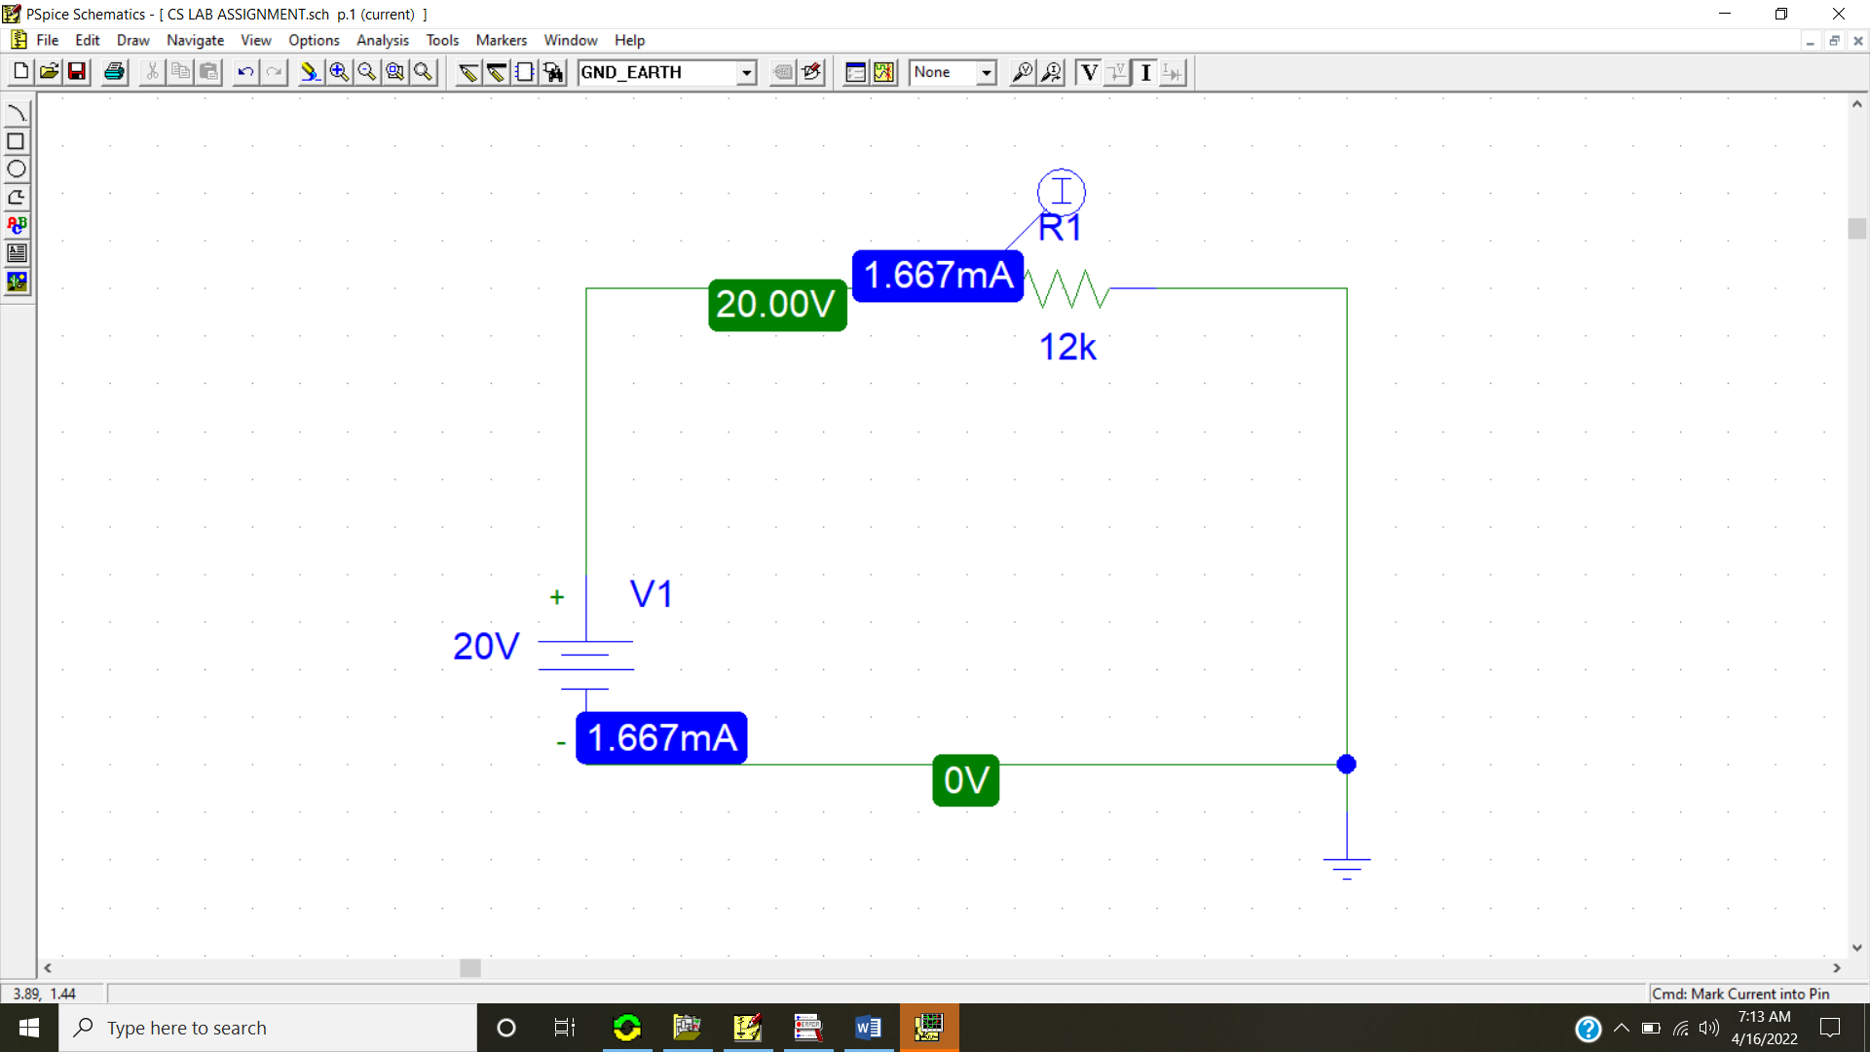

**25 Volt DC source and 12k Resistor**

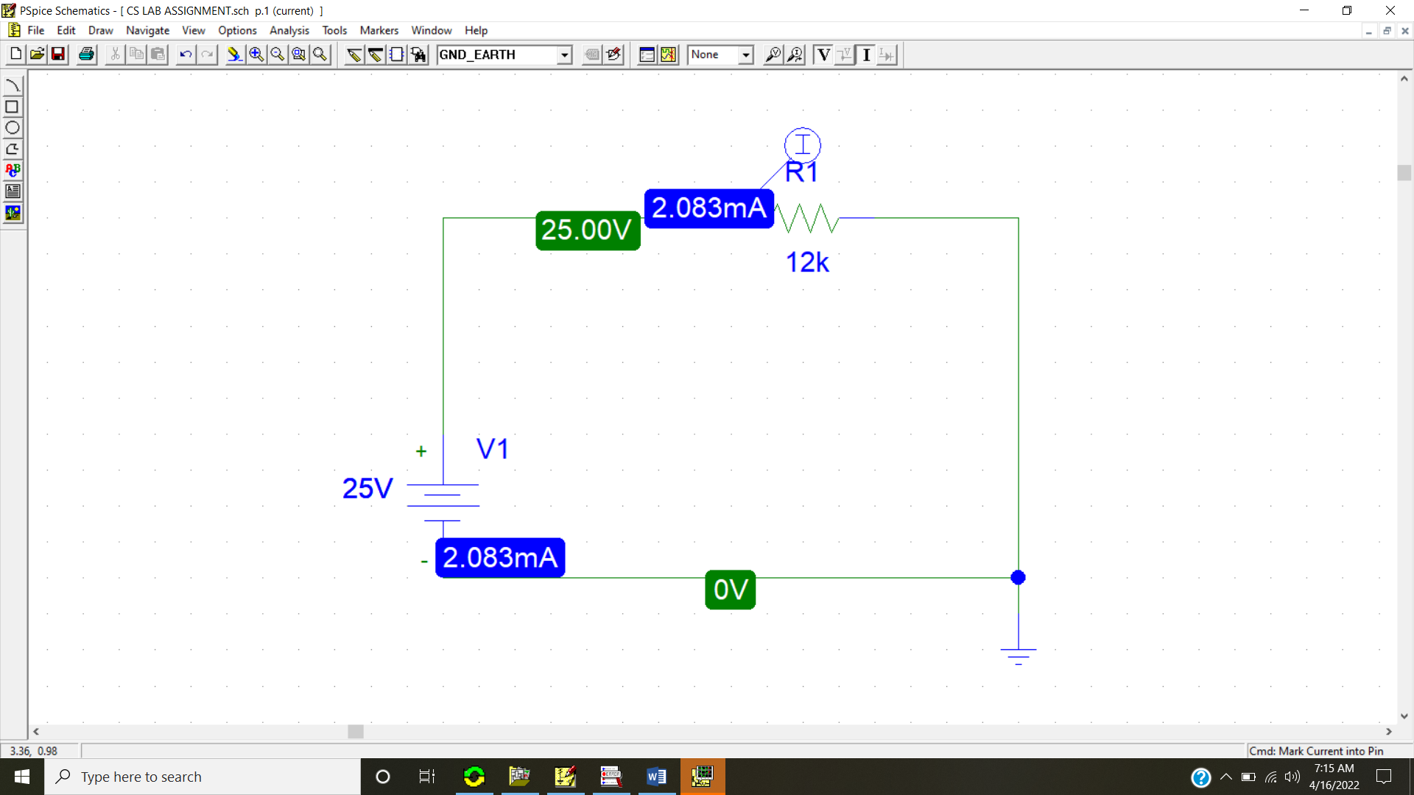

**30 Volt DC source and 12k Resistor**

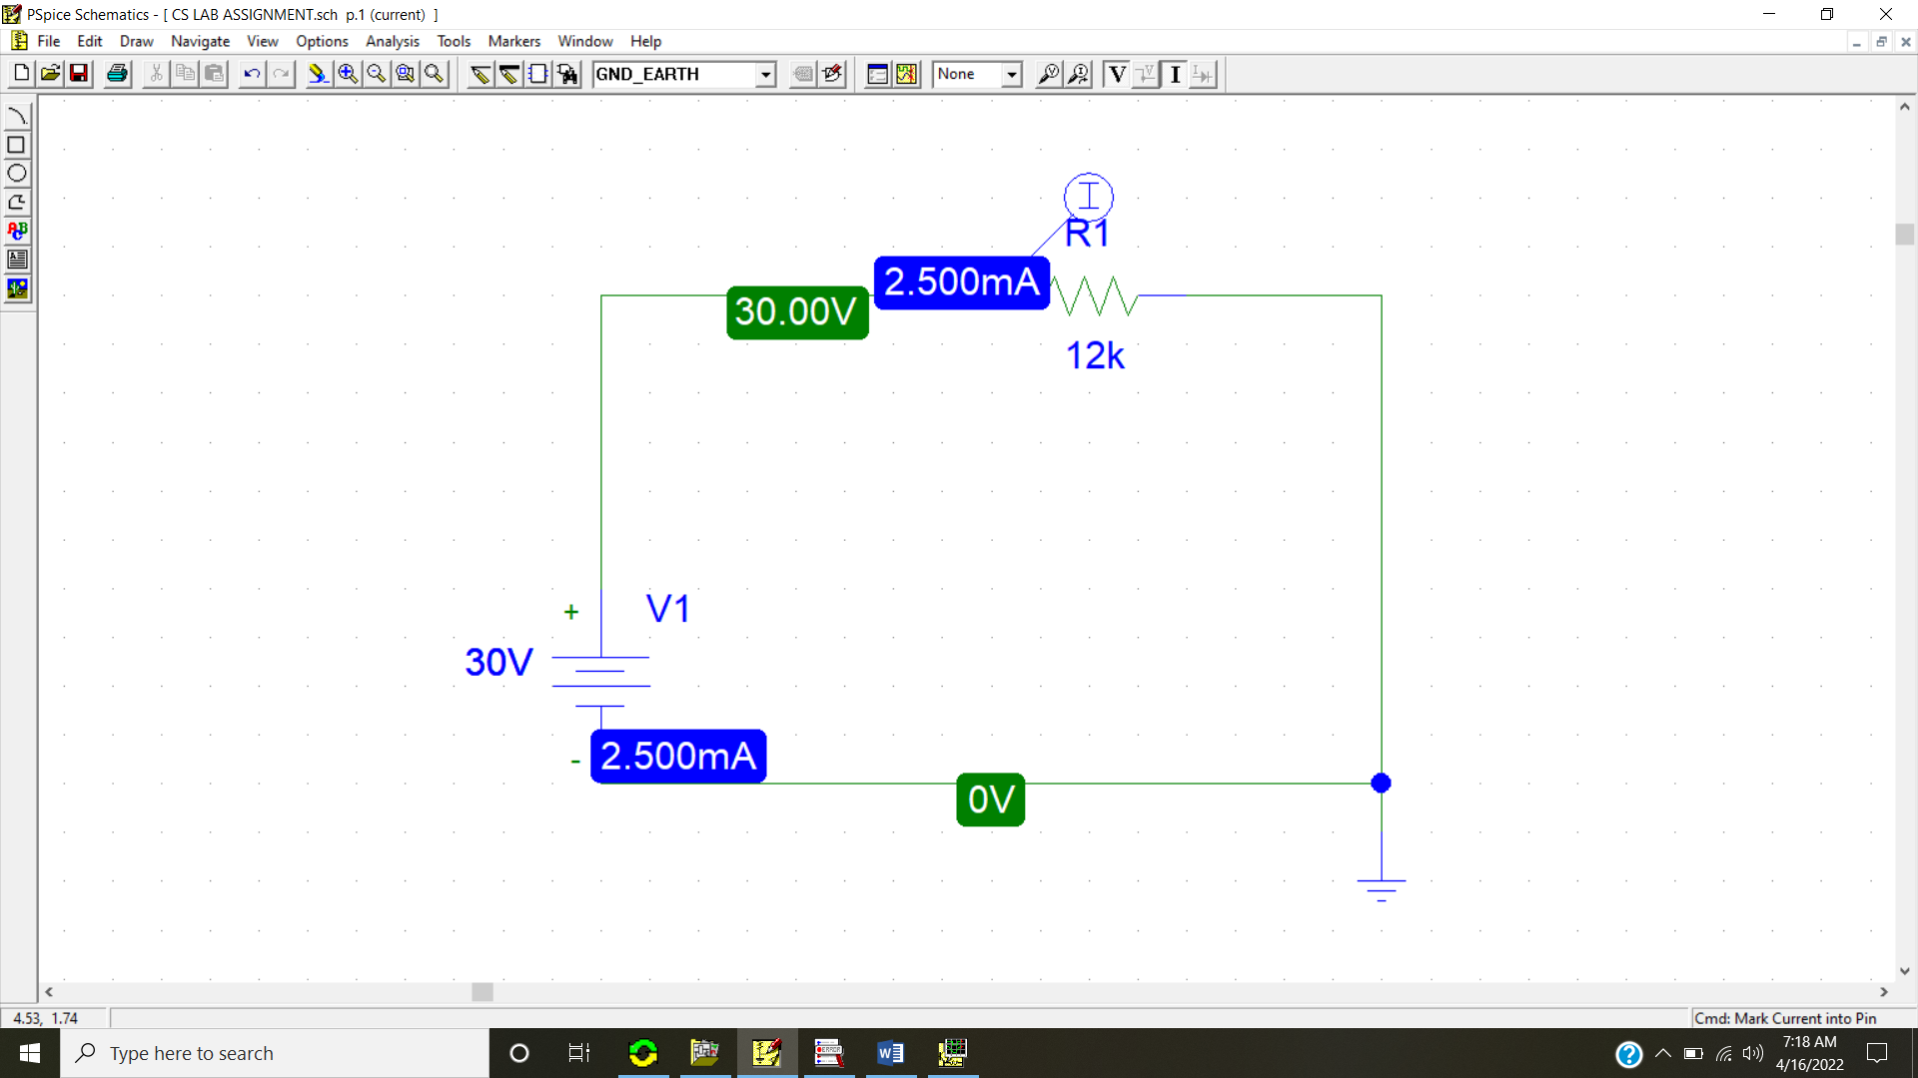

**Observation:**

**R = 12k Ω**

|  |  |  |
| --- | --- | --- |
| **Serial Number** | **Voltage (v)** | **Current (A)** |
| 1. | 5 | 416.67 µA |
| 2. | 10 | 833.33 µA |
| 3. | 15 | 1.250 mA |
| 4. | 20 | 1.667 mA |
| 5. | 25 | 2.083 mA |
| 6. | 30 | 2.500 mA |

**Graphs:**

**5 Volt DC source and 12k Resistor**

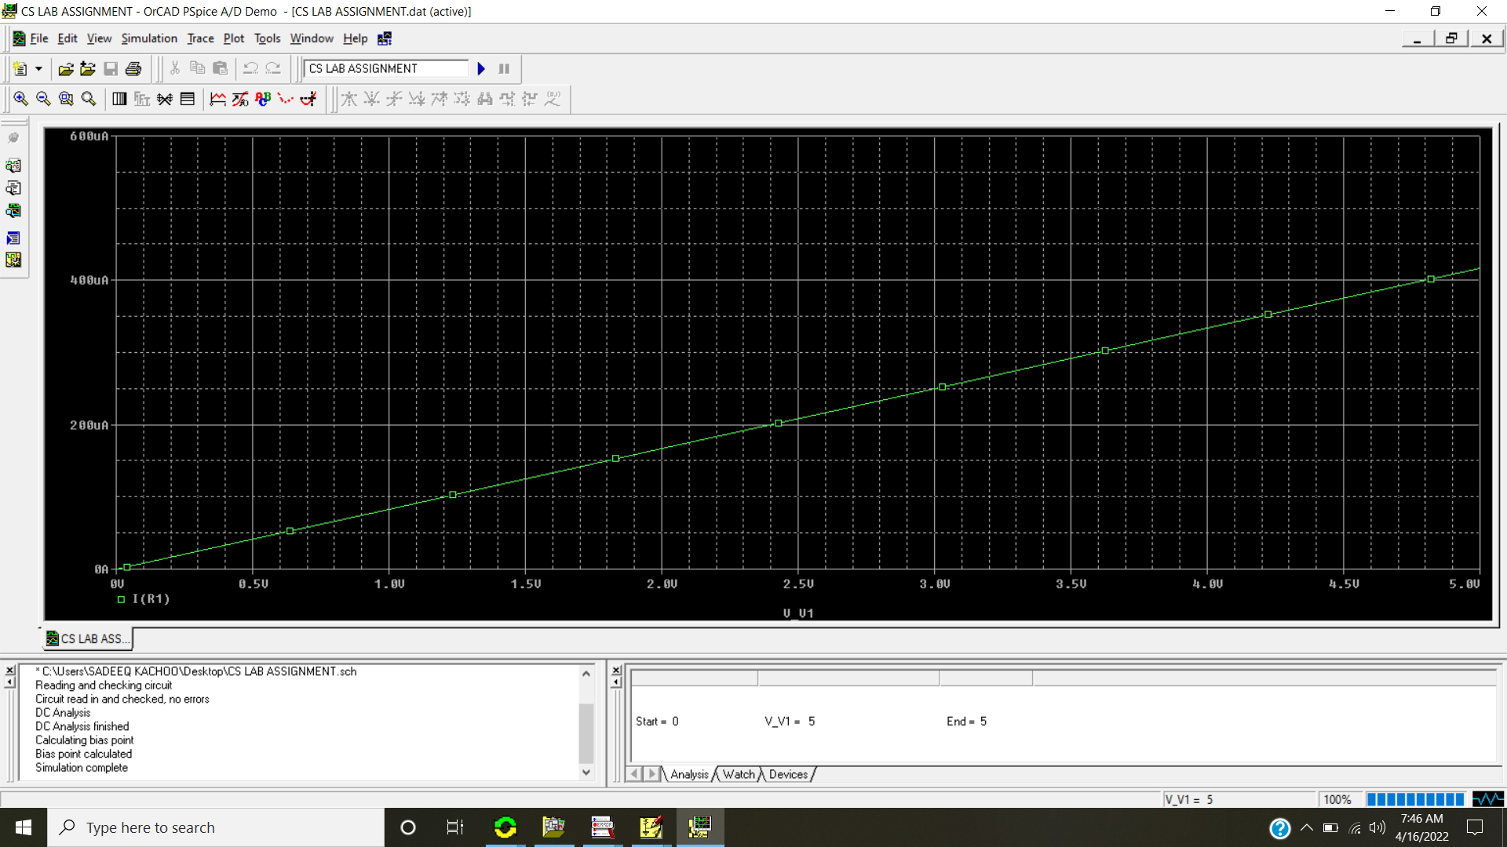

**10 Volt DC source and 12k Resistor**

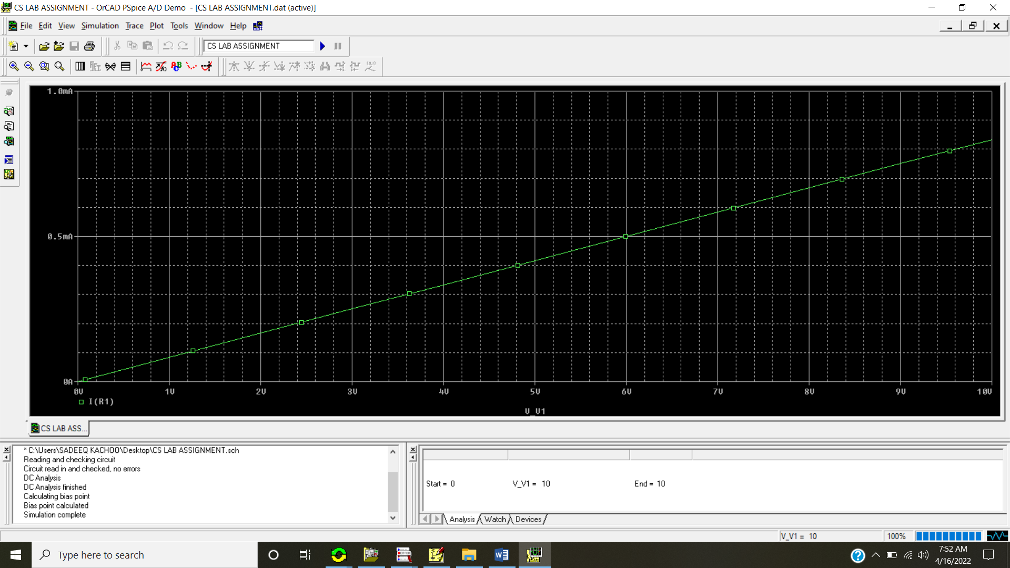

**15 Volt DC source and 12k Resistor**

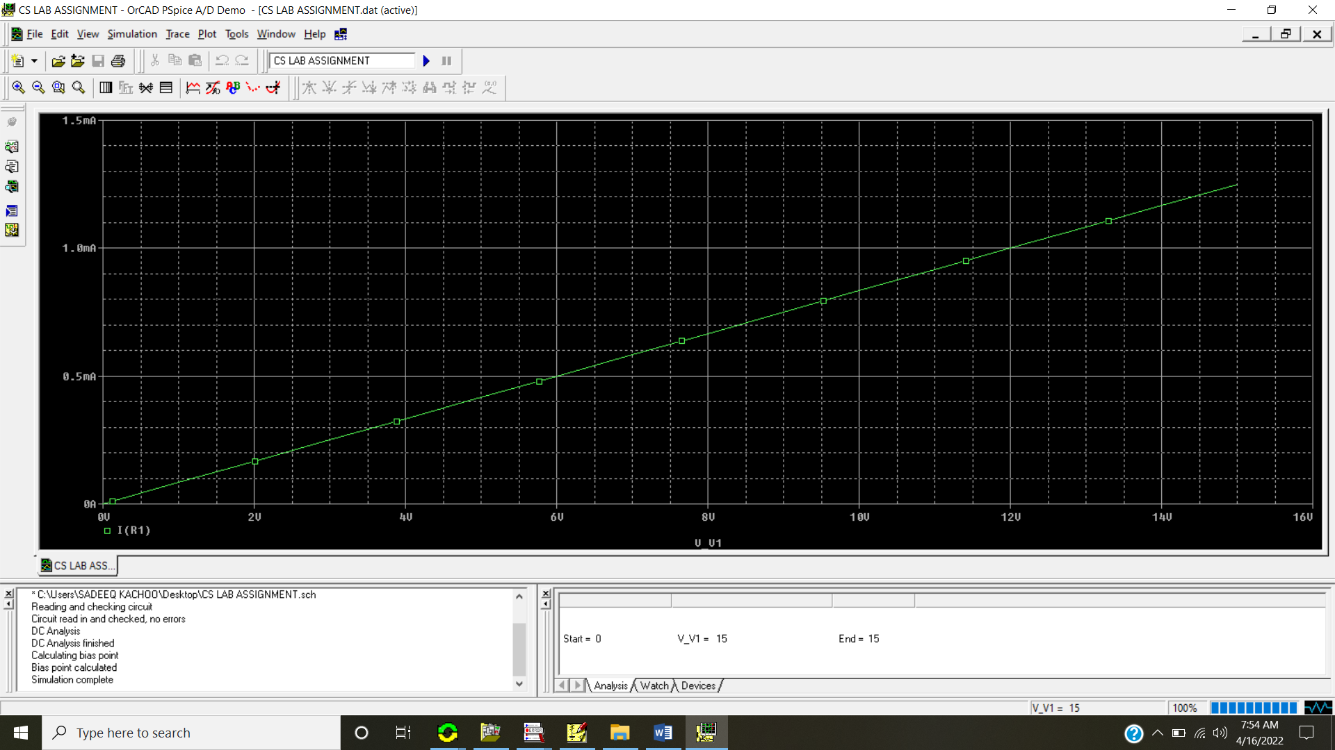

**20 Volt DC source and 12k Resistor**

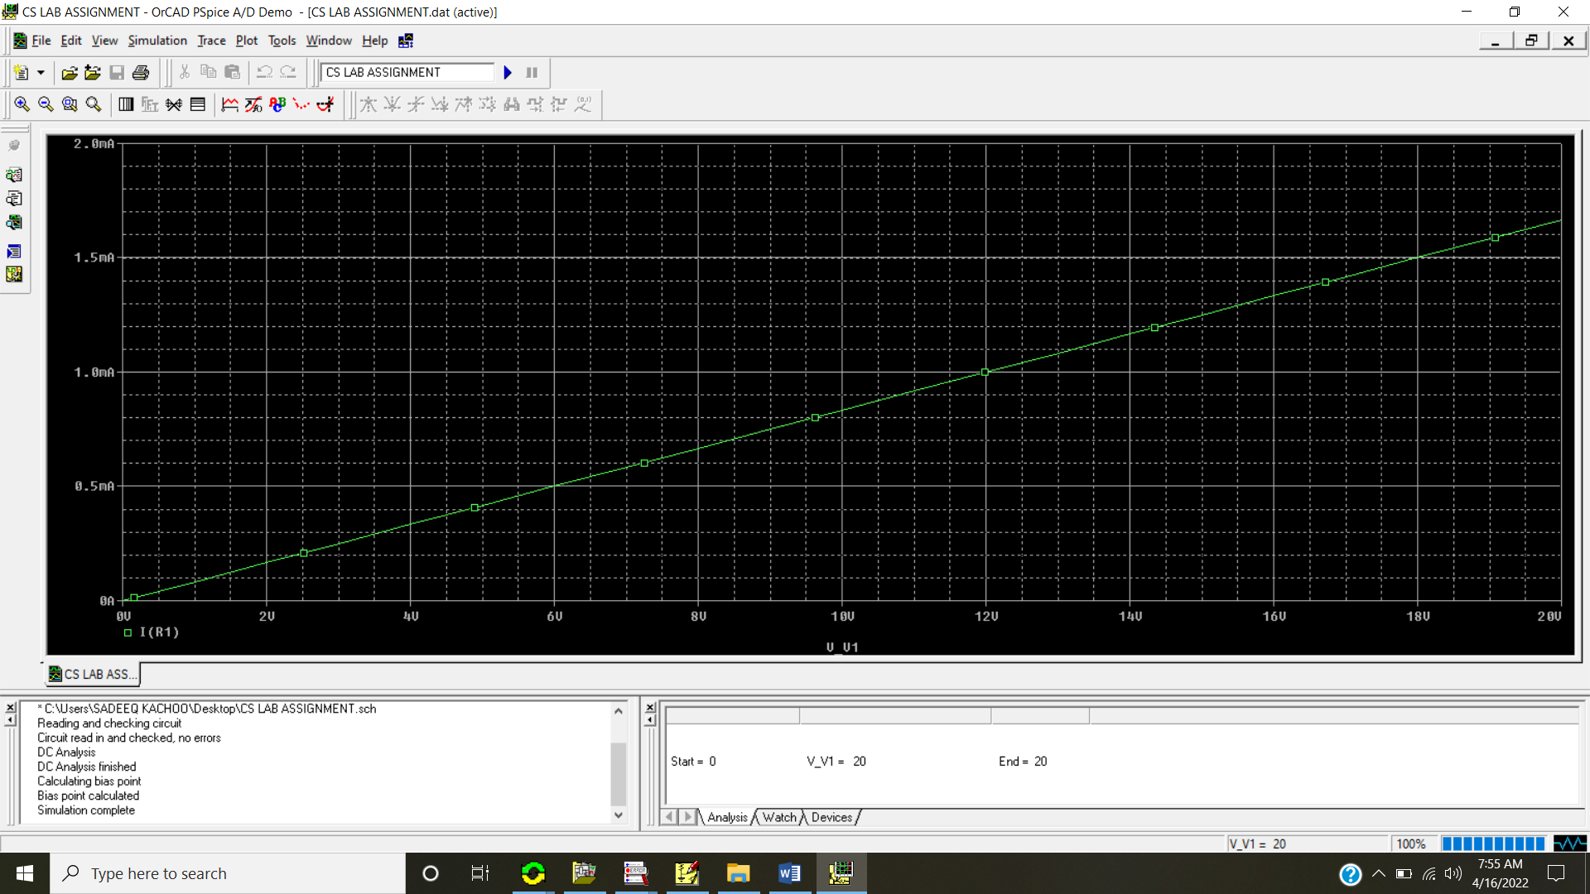

**25 Volt DC source and 12k Resistor**

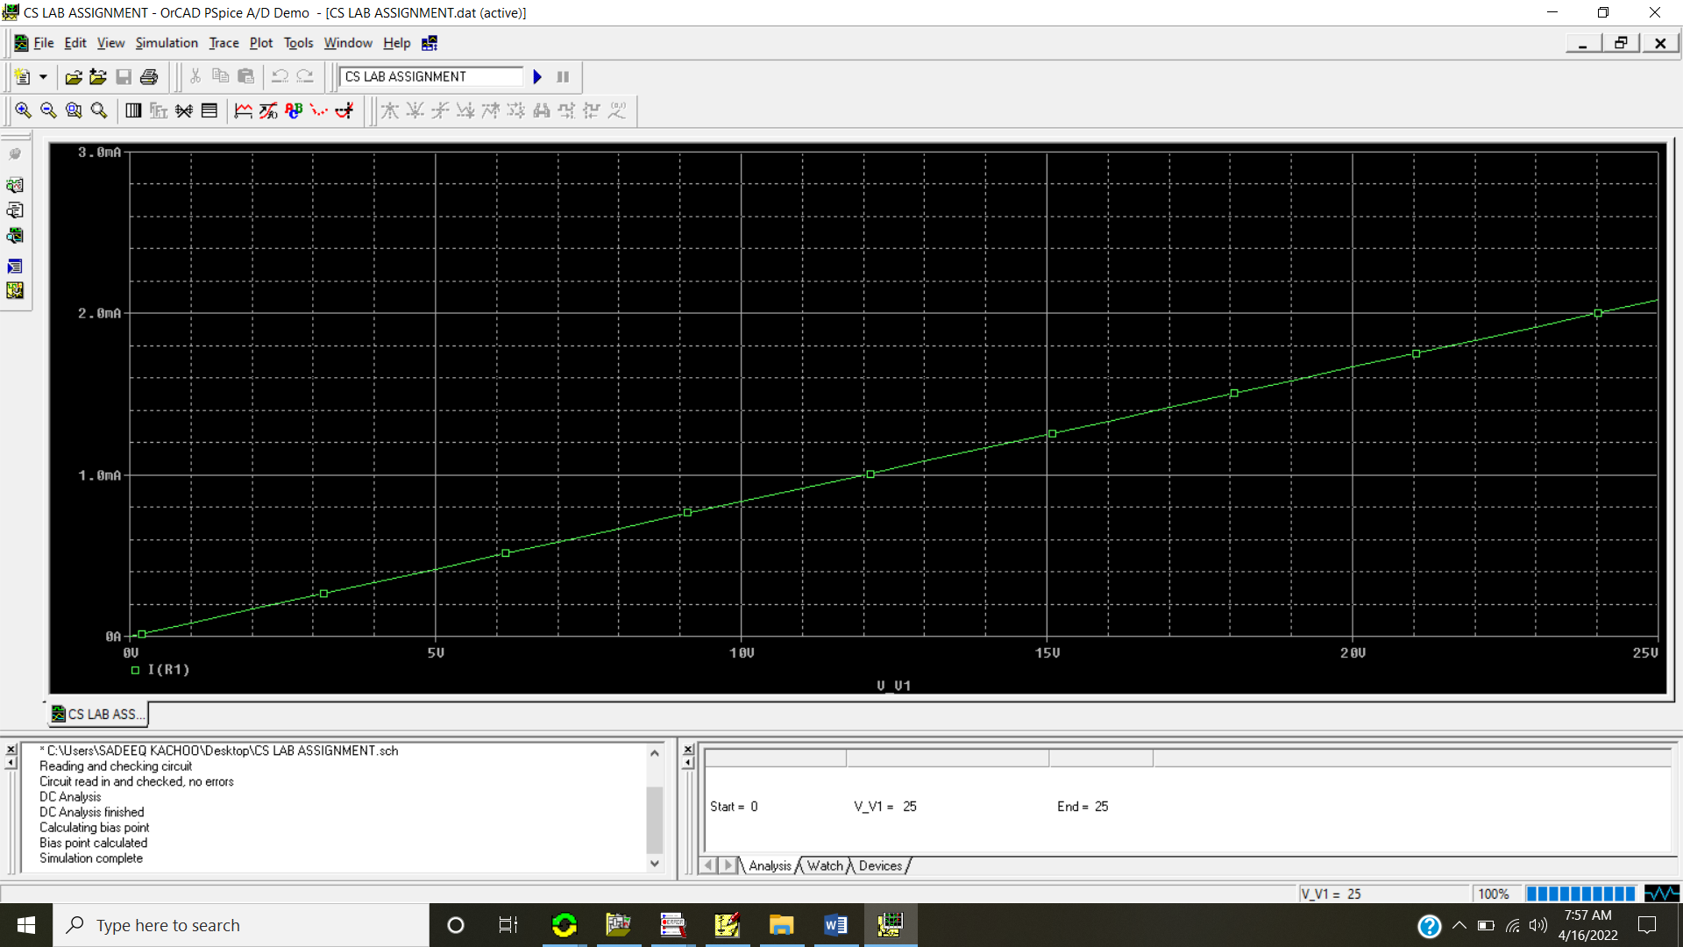

**30 Volt DC source and 12k Resistor**

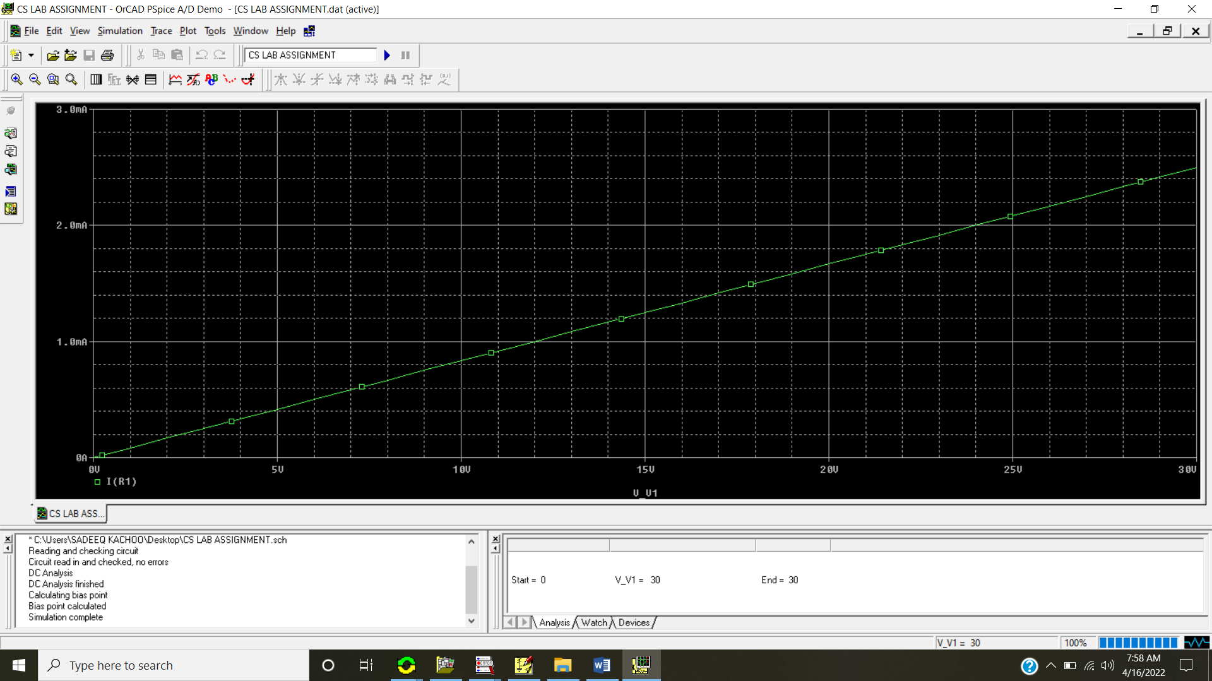

**Conclusion:**  
  
The data shows that the higher the voltage, then the higher current, meaning that the voltage is directly proportional to the current, which is what ohms law states.

A straight line graph is obtained when we plot a graph of voltage vs current.